**A Level History Summer Project 2025:**

**The Civil Rights Era – 1861 to 1968.**

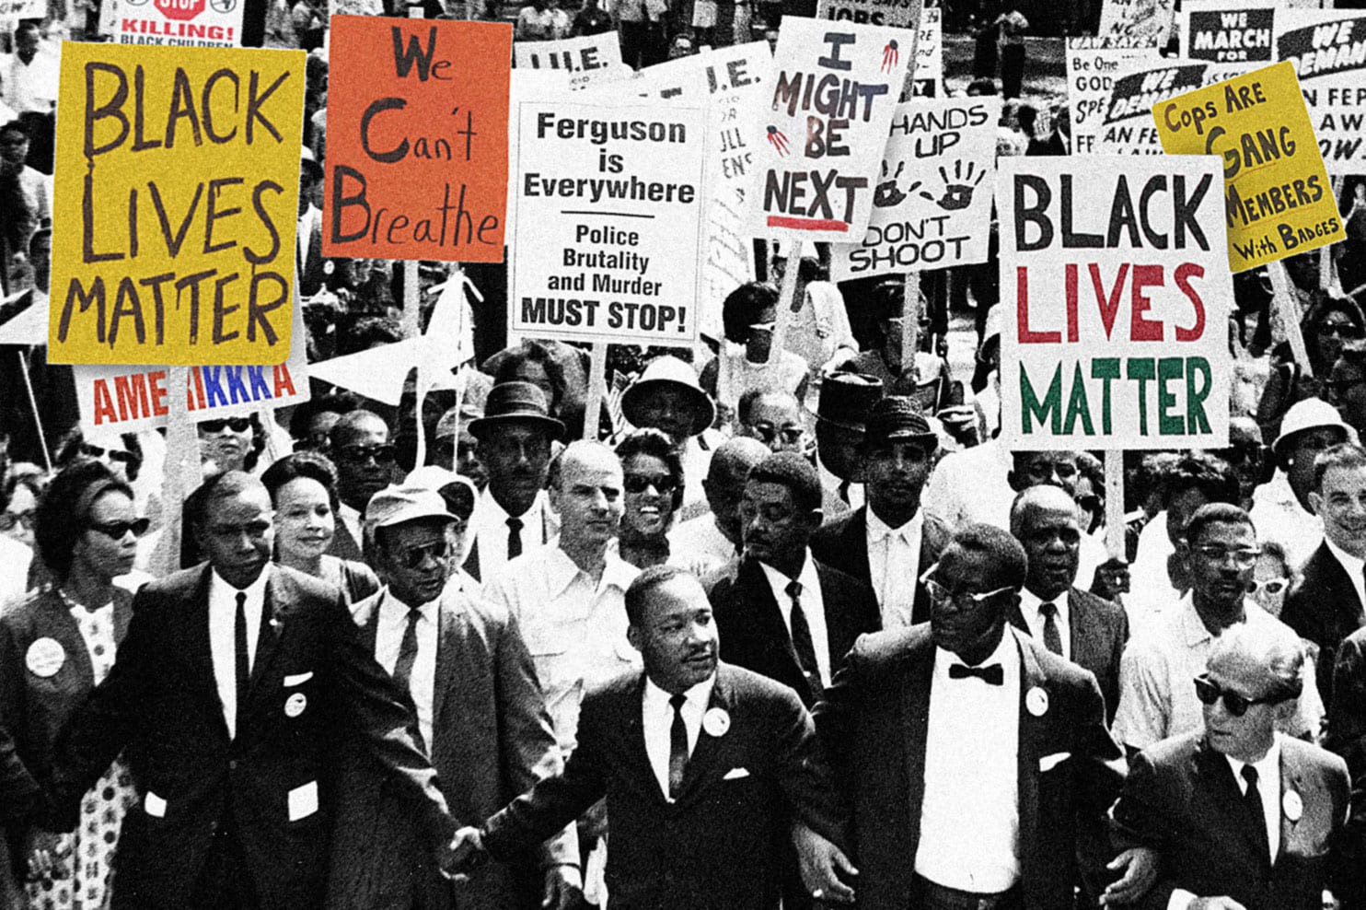

**Civil Rights are the rights someone has in society, as upheld by the law; in this context, the rights of African Americans in USA. The most important Civil Rights in this period included the right of freedom of speech, freedom of the press, freedom from servitude, equality in the law and the right to vote. Above all, Civil Rights to black Americans meant the right to equality with white Americans.**

**While slavery was totally legal in the USA in 1861, it was mostly the Southern states that still exploited black people as slaves. This was because the Northern states had industrialised as a result of the Industrial Revolution; as they had gained more and more factories there was less need for manual labour so by 1861 slavery was largely non-existent in the North. Nevertheless, on the plantations in the South they were necessary to keep the primarily agricultural economy there going. This was a major factor in the Civil War that marks the beginning of this period.**

**Part One – The American Civil War and its impact on Civil Rights**

**Task 1: Documentary and questions**

Watch the following Documentary about slavery and the outbreak of the Civil War (America the Story of the US Episode 4 – Division) *and answer the 12 questions below:*

<https://www.youtube.com/watch?v=SyJlbqiZABQ>

**Questions to answer**

1. What is the major economic difference between the North and the South?
2. Why was the Cotton Gin so important?
3. Why is slavery critical to the economy of the South?
4. Why did slavery expand West?
5. Who is Frederick Douglass?
6. Who is Harriet Tubman?
7. How does the new Fugitive Slave Law take slavery to the North?
8. Why does it cause increasing tensions between the North and South?
9. What happens in Kansas? Why is slavery the root cause of conflict?
10. What does Abraham Lincoln think of slavery?
11. Why does the election of Lincoln push the country towards Civil War?
12. What does Lincoln do to avoid a war with the South?

**Task 2:** Now use your learning to answer the following questions, either in an annotated flow-chart or mind map.

1. **How did the South and North of America differ about the importance of Slavery and why?**
2. **What role does each branch of the American government play: Executive, Presidents, and Legislative?**

Useful websites to help you:

<https://www.jstor.org/stable/43598314?seq=1>

<https://www.usa.gov/branches-of-government>

**Part Two: The Civil Rights Era in American History – an Overview.**

**Read the article - 'We Are Determined to Struggle for Justice and Equality': The Civil Rights Era in African American History by Quincy Lehr**

As you read**, create a detailed flowchart showing the progression of Civil Rights and Civil Rights activism from 1860 under Abraham Lincoln through to the late 1960s.**

This must cover:

* The Civil War
* Reconstruction
* Jim Crow segregation and violence against African Americans
* The NAACP
* Supreme Court victories
* Dr Martin Luther King Jr. and his actions
* Civil Rights organisations and their actions
* The March on Washington
* Malcolm X

**Part Three: The role of Presidents in Civil Rights in America.**

* Create a timeline of the key Presidents between 1861 and 1965: Abraham Lincoln to Lyndon B. Johnson. Make sure you include them ALL!
* Create a fact file for each President - focus only policies and laws that relate to African Americans and race relations. (this can be bullet pointed and only needs to be ¼ of an A4 page per president)

Useful Websites:

* <https://www.whitehousehistory.org/the-presidents-timeline>
* <https://www.history.com/topics/civil-rights-movement/civil-rights-movement-timeline>
* <https://www.preceden.com/timelines/310201-civil-rights---presidents>