A level Media Summer Tasks 2024

Task One:
Question: Fandom and fan-made materials are essential for the success of any C21st media text. To what extent do you agree?
You will need to research your own text and write your own response to this question.
This should include examples from all three media platforms (print, moving image and e-media, just like the examples we have looked at for the film Deadpool and Wolverine – please DO NOT use this in your essay! )
If you are stuck, you might want to look at examples from TV (House of the Dragon, Fallout), Video Games (Call of Duty, Starfield) or from within the music industry (Eras Tour, Sabrina Carpenter).
You will need to submit this in September to be marked. Your essay should include a minimum of 500 words. You may handwrite it or type it, but you are reminded of the need for clear communication.

Task Two:
We would also like you to use your production skills to create your own piece of fandom for the same text as your essay. This can be from any platform but should demonstrate the advantages of participatory culture and show us your understanding of how promotion works.
You do not have to be a photoshop/editing whizz – you could construct fan art, TikTok videos or a fan made social media account.
This will also need submitting in September via our teams page.

Helpful links:

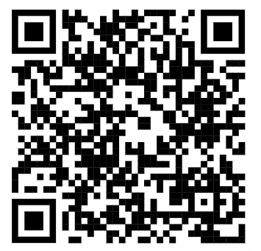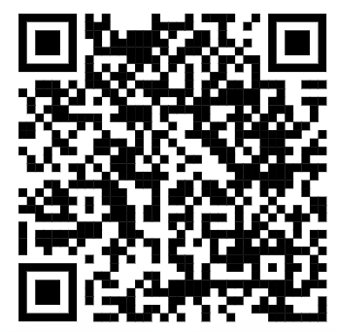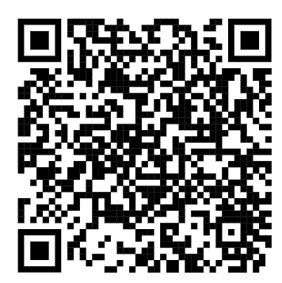
Jenkins Video More Jenkins Star Wars Fandom
Preparing for Media Studies Reading List:

Follow the following on social media:
- Mrs Fisher’s AQA A level youtube videos https://www.youtube.com/channel/UCUKrxp4BcJrGLzmqAhCjASg/videos
- Make sure you follow the following on all social media platforms: Taylor Swift, The Daily Mail, The Guardian, GQ, The Voice (http://www.voice-online.co.uk) and The Gentlewoman Magazine.

Get a good understanding of how the media works:
- How is the BBC funded?
https://www.bbc.com/aboutthebbc/governance/licencefee

- How is UK media regulated?
https://www.article19.org/data/files/pdfs/publications/uk-media-regulation.pdf

- How has technology impacted on the media?
https://www.bbvaopenmind.com/en/articles/first-the-media-then-us-how-the-internet-changed-the-fundamental-nature-of-the-communication-and-its-relationship-with-the-audience/

- How society has impacted the representations used within the media (useful for those also studying sociology)
https://www.shortcutstv.com/blog/wp-content/uploads/2019/04/mm_representations.pdf

Any further questions please contact us at:

Ctull@toothillschool.co.uk
Abell@toothillschool.co.uk

