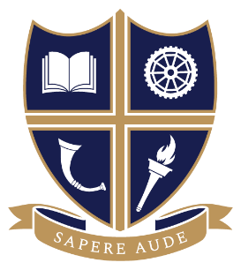
SUBJECT: HISTORY
EXAM BOARD: AQA
Course Overview | Paper 1C – Tudors (40%)  Year 12 Consolidation of the Tudor Dynasty, England, 1485-1547  Year 13 Turmoil and Triumph, 1547-1603  Paper 2R - Cold War (40%)  Year 12 To the Brink of Nuclear War, 1945-1963  Year 13 From Détente to the end of the Cold War, 1963-1991.  Non-Examined Assessment (NEA): to be completed in Year 13  20% of the overall grade is produced through a 4,500 personal study using primary sources and historians, exploring a topic of interest.
Essential text books and reading list | Core reading and Textbooks:  - Tudors: Oxford AQA History for A Level: The Tudors: England 1485-1603, By Michael Tilbrook.  - Cold War: Oxford AQA History for A Level: The Cold War c1945-1991, by John Aldred.  Useful revision guides:  - Oxford AQA History for A Level: The Cold War 1945-1991 Revision Guide  - Oxford AQA History for A Level: The Tudors: England 1485-1603 Revision Guide  If you want an easy intro read:  - The Tudors: A Very Short Introduction, John Guy.  - The Cold War: A Very Short Introduction, Robert McMahon  - John Lewis Gaddis: The Cold War

